**Fictitious Forecast Analysis, Excel Sample**

**Rogier Cosmetics Executive Brief**

**John Abbott**

**External Challenges**

With the cosmetics industry shifting toward more environmentally sustainable products because of customer concerns, RCI must attend to the concerns of material and manufacturing outside of the firm. The challenge is negotiating a supplier that can meet the demand, and be cost effective. This includes labor, material and shipment costs. The supplier and manufacturer must also adhere to the company’s statement on environmental sustainability.

With this subcontracting, the company is also concerned about exposing their product line to outside vendors. So in addition to limiting the outside production, the company also needs to be concerned about their vendor candidate’s adherence to non-disclosure.

Outsourcing production can lower labor costs, but raise shipping costs. RCI should make calculations on whether foreign production is profitable. Foreign cosmetics markets in China and India have been major parts of the consumer market, and other Asia-Pacific countries have grown to join them. RCI should keep up with these markets, and make marketing efforts toward then, especially if production occurs in these places. Labor regulations in these areas is also a main concern, especially with the US public’s concern for worker treatment. The article on Outsourcing by Nibusiness Info UK cautions companies that want to maintain flexibility in production that outsourcing dramatically lowers flexibility due to the rigidity that foreign contracting can have. This will be problematic to RCI as they try to develop new manufacturing technologies and techniques.

Competitor activity is a concern for RCI as it shifts into an online subscription service. RCI needs to keep up with quality, convenience and pricing demanded by their competition.

**Internal Challenges**

Consumer demands also affect the company’s internal challenges. The company itself must gear production toward sustainable products, most especially packaging. With other companies developing technologies to improve in these areas, like 3D printing environmentally friendly packaging, RCI is challenged to develop techniques and technologies of its own in these areas.

Standard production challenges apply to RCI. The company needs to use analytics to achieve the most cost effective production it can, with concerns toward supply and demand. The company should not produce more than it can sell. At the same time, the company should keep up with consumer demand. Failing to keep up with demand will not only cause a loss in potential sales, but decrease the company’s reputation, especially considering that customers are paying for on-time delivery of products regularly.

**Goals**

-Transition to environmentally sustainable materials and production

-Obtain cost effective and trade-safe production with internal manufacturing, subcontracted manufacturing and outsourced manufacturing

-Obtain an optimal manufacturing partner

-Sustain and grow customer loyalty

-Maintain convenient and affordable e-commerce system

**SWOT Analysis**

Strengths

-Popular e-commerce system maintains loyalty and income

-Connections with potentially good manufacturing partners

-Growing demand in RCI products

Weaknesses

-Internal firm is not capable of meeting production demands

Opportunities

-Growth in RCI product demand creates an opportunity to increase customer base

-Marketing convenient subscription packages will increase customer base and loyalty

-Marketing sustainable products and technologies will increase customer base and loyalty

-Outsourcing production lowers labor costs and increases proximity to foreign consumer base

Threats

-Product line information is exposed to third party manufacturers

-Competitors are shifting to e-commerce and trying to make more affordable and convenient subscription models, threatening RCI loyalty

-Outsourcing production to firms with poor worker treatment threatens company reputation, and reduces flexibility of production

**Problem Statement**

RCI’s challenges relate to shifting market opportunities and demands. The company needs to optimize production by obtaining a manufacturing partner that is cost effective and able to adhere to non-disclosure agreement. The company should develop technologies and production methods that are efficient and sustainable. The company should consider viable and ethical outsourcing opportunities that maintain flexible production. The company should maintain an optimal e-commerce system by marketing convenience, affordability and quality.

**Current Summary Table**

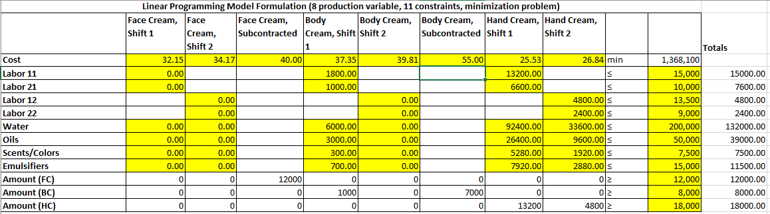

Shown above, the summary table of optimized production shows how best to utilize each labor shift or subcontract. Note that each labor shift of Rogier’s facility is used maximally. The following decision tree examines the cost-benefit of adjusting the production plan as prices change. The best course of action regardless is to continue to make maximal use of the in-house production capability.

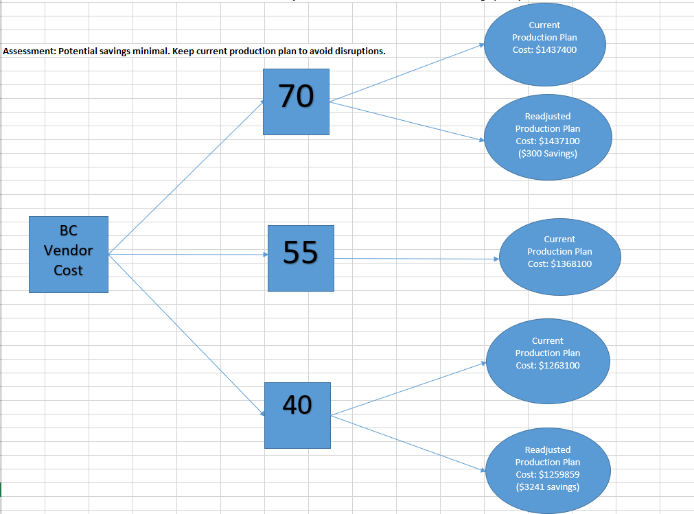

**Forecast**

**Body Cream**

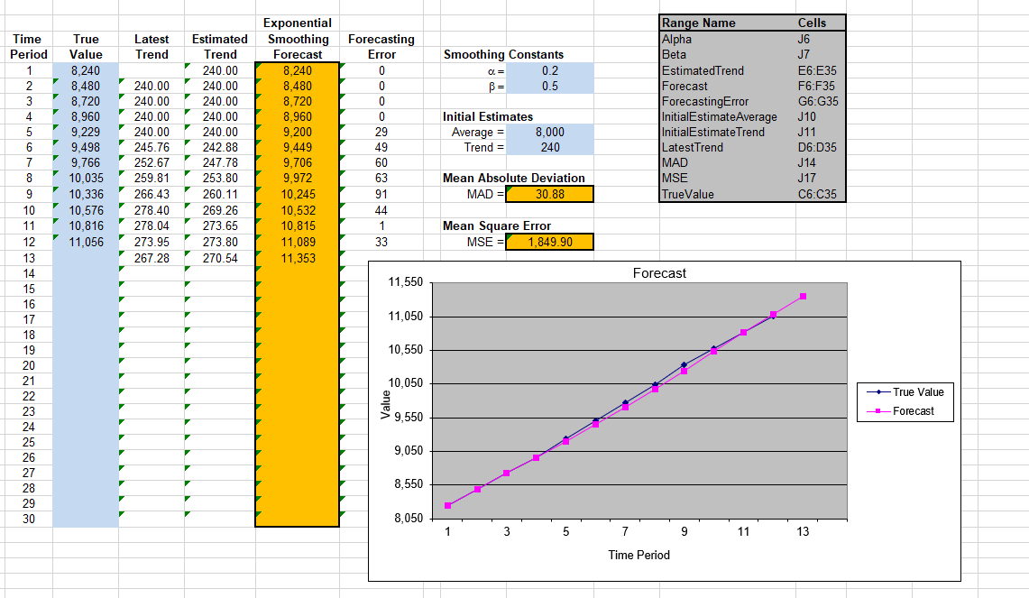

**Face Cream**

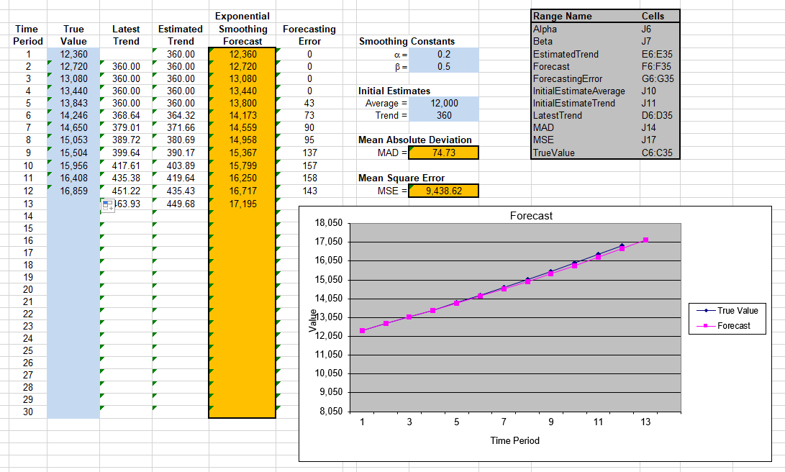

**Hand Cream**

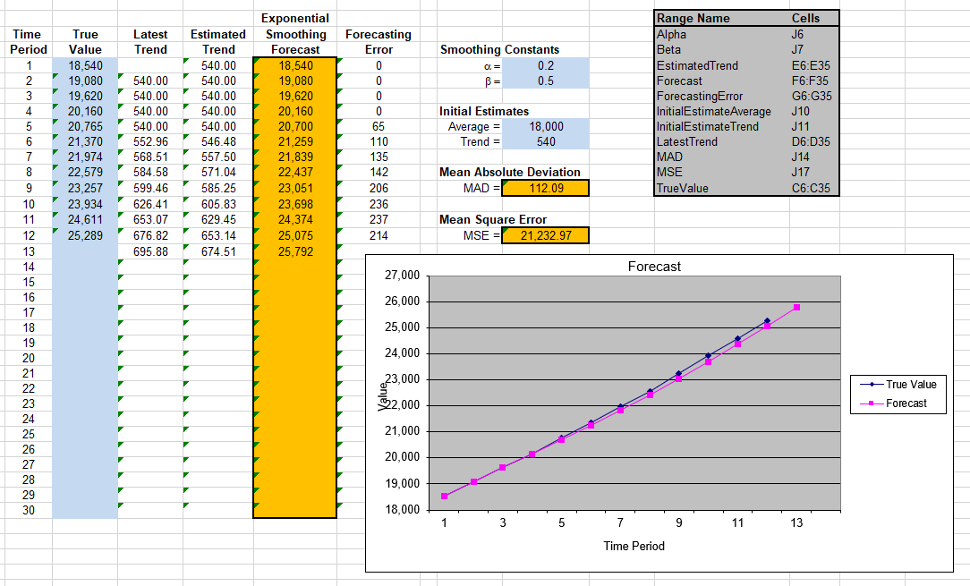

**Recommendations**

The forecast estimates that in three years, if trends continue, Body Cream will be at a demand of 11,353 containers, Face Cream at 17,196 and Hand Cream at 25,792. This is considerable grown in just three years, and poses a great consideration on whether or not to outsource. The company’s current production cannot meet such a demand.

Let’s assume that the partner manufacturer is capable of meeting that demand. This means that at $40 per unit of Face Cream alone, the production cost will be over $687,000. Even if Rogier were able to keep the production fully in house by expanding their facilities, that still comes to a production cost around $587,000, optimistically. It’s not a question of whether the company can still keep a profit in these conditions, it’s more a question of the conditions to come and whether it is optimal to continue local production.

It is tempting consider the option of foreign production. Lower labor costs are certainly appealing, and labor in this production constitutes the majority of the production cost. However, let us consider other factors.

Forbes considers some advantages and disadvantages of outsourcing. The advantages include not having to hire employees, access to a larger talent pool and lower labor cost. The key factor in our consideration here is the lower labor cost. Hourly rates for employees overseas can be as low as 52 cents an hour (“Reversal of the Offshoring Tide”, McBeath, 2013). This would reduce the cost of production per unit significantly. Forbes’ disadvantages include lack of control, communication issues and problems with quality. The key issue here is the lack of control. With such growth as indicated by the forecast, Rogier is going to want to be on top of its production methods. The larger cosmetics companies are pushing ahead by researching and developing production techniques and formulas. Rogier, to stay ahead, needs to make the same strides, and outsourcing will hinder any changes to production. The concern of quality is also major. E-commerce models are popular nowadays, but there is a tendency of e-commerce companies to fall victim to a certain narrative: The company starts out with great quality products that grow popular, the company starts struggling to upkeep demand, the product quality drops off significantly, and the company suffers tremendously from poor reputation and customer turnover. It is of great importance that Rogier maintain its quality, if not improve it, as its demand increases. Forbes also takes a moment in its article “The Pros and Cons of Outsourcing” to mention company culture, and the impact outsourcing has on it. In addition to reputational concerns, the culture and attitude of company employees is poorly impacted when a company switches to outsourcing, and poor employee culture translates immediately to lower productivity. This is a serious problem because according to “Reversal of the Offshoring Tide”, in-house employees are able to be ten times as productive as offshore employees thanks to the technology available to us here. The impact would be considerable.

With the concerns raised by Forbes, the question becomes thus: Does the benefit of outsourcing outweigh the risks and costs posed by it? To further compound this, “Reversal of the Offshoring Tide”, an article written for ChainLink Research by author Bill McBeath, the benefits of outsourcing are becoming smaller. With the forecast above going into the next three years, we can assume this trend will continue and the benefits will shrink. Fuel costs are rising, labor costs overseas are rising, business in foreign countries are taking precedence over western businesses, and distant management becomes harder and harder. On the bright side, the factories in those countries are improving, which much like in the west, are using technology to increase worker productivity, but it’s still small compared to in-house worker productivity.

Given the risks and challenges at play, my recommendation is for Rogier to invest in its own in-house manufacturing in the coming years, to enable its facilities to meet as much demand as possible. The remaining demand can be met by local third party manufacturing, and if demand continues to exceed local capability, resort to outsourcing the rest. This strategy will ensure that local employees stay productive and of high morale, given that they are being used maximally, and the cost of production will be kept at a minimum.

Quality however, is still a concern. I would propose a premium pricing option, depending on how things progress. Finer packaging, more elegant advertising and high quality locally produced products will produce a “high-end” product culture among the customer base and the company. With the increased demand, a premium price should be a success, and the company can enjoy higher profits and better expansion as a result. Investing in the image of a fine and high-life product will allow the company to keep a higher premium price, while still meeting basic demand.

**Summary**

With mathematical, economic and cultural analysis and research performed, Rogier Cosmetics should make maximal use of its own production facilities. Furthermore, Rogier Cosmetics will benefit in many ways from expanding its own production capabilities as its product grows in demand. This course will provide the best growth for the company financially and culturally.

It is tempting to look at the reduced production costs obtained from outsourcing without considering the indirect costs. As stated above by the relevant research, outsourced production is becoming less and less financially beneficial. Additionally, the American public is increasingly concerned about the humanistic costs of outsourcing, especially for products that they are associating with their own health as well. A solid trust in Rogier’s brand is paramount to ensuring the company grows as forecasted. Making maximal use of Rogier’s own production facilities, and expanding such facilities will keep costs low, create American jobs, improve customer trust and elevate employee culture. Keeping to this course will produce the highest change that the company will grow as forecasted.

**Citations**

McBeath, B. (2013, January 8). *Chainlink research : Research :reversal of the offshoring tide*. Research. Retrieved July 24, 2022, from http://www.clresearch.com/research/detail.cfm?guid=0679757B-3048-79ED-9991-E087887A811C

Patel, D. (2021, December 10). *The Pros and cons of outsourcing*. Forbes. Retrieved July 24, 2022, from https://www.forbes.com/sites/deeppatel/2017/07/17/the-pros-and-cons-of-outsourcing-and-the-effect-on-company-culture/?sh=f0721eb562d6

Hall, O. P., & Ko, K. (2017). Rougir Cosmetics International: Production Optimization. *Ivey Publishing*. https://doi.org/https://services.hbsp.harvard.edu/lti/links/content-launch

*Outsourcing*. Advantages and disadvantages of outsourcing. (n.d.). Retrieved June 25, 2022, from https://www.nibusinessinfo.co.uk/content/advantages-and-disadvantages-outsourcing